Library Management System

## Domain Analysis Documentation

**Project:** LibraryAssistantApp  
**Date:** October 25, 2025  
**Version:** 1.0

1. Name of the project: Library Assistant App

# 1. DOMAIN ANALYSIS General Field of Business

## Overview

The Library Assistant App operates within the Library and Information Services (LIS) sector, which is part of the broader education and knowledge management industry. This domain encompasses the organization, preservation, and dissemination of information resources to serve communities, educational institutions, and organizations.

# 2. Terminology and Glossary

### Circulation Operations:

**Issue/Checkout:** Process of lending a book to a patron

**Return:** Process of receiving a book back from a patron

**Reservation/Hold:** Request to borrow a book currently unavailable

**Renewal:** Extension of a loan period

**Overdue:** Book not returned by the due date

**Fine:** Monetary penalty for late returns or damaged materials

### Collection Management:

**Acquisition:** Process of obtaining new materials for the library

**Accession:** Recording and adding new items to the collection

**Deaccessioning/Weeding:** Removing outdated or damaged items

**Inventory:** Physical count and verification of collection items

### User Management:

**Patron/Member:** Registered library user

**Membership:** User account with borrowing privileges

**Patron Record:** User's borrowing history and account information

**Borrowing Limit:** Maximum number of items a user can borrow simultaneously

### Digital Services:

**E-book/Digital Book:** Electronic version of a book

# 3. General Knowledge and Understanding of Business Environment

## Key Business Challenges

### Operational Challenges:

* Managing large inventories efficiently
* Tracking items across multiple locations
* Handling peak demand periods (exam seasons, summer reading programs)
* Preventing loss and damage to materials
* Managing staff schedules and workloads

### Technological Challenges:

* Digital transformation and system migrations
* Cybersecurity and data privacy
* Integration of legacy and modern systems
* Mobile accessibility requirements
* Supporting diverse devices and platforms

# 4. Tasks and Procedures Currently Performed

New User Registration, Account Updates, Account Maintenance, Search and Discovery, Reservation (if book unavailable), Check-Out Process, Renewal Process, Return Process, Fine Calculation, Fine Collection, Fine Waivers/Adjustments, Collection Assessment, Book Selection, Ordering Process, Cataloging and Processing, Regular Inventory Audits, Weeding Process, Digital Collection Development, E-book Circulation, Online Catalog Access (OPAC), Digital Reference Services, Circulation Reports, Financial Reports, Collection Reports, User Reports, User Role Management, System Configuration, Data Backup and Security

# 5. Customers and Users

## Primary User Groups

Students (K-12 and Higher Education), Academic Researchers and Faculty, General Public/Community Members, Children and Young Adults, Senior Citizens, Library staff

## User Demographics and Characteristics

### Age Distribution:

* Children (0-12): 20%
* Teens (13-18): 15%
* Young Adults (19-30): 30%
* Adults (31-60): 25%
* Seniors (60+): 10%

### Technology Adoption:

* Tech-savvy (prefer digital): 45%
* Moderate users (hybrid): 35%
* Traditional (prefer physical): 20%

### Usage Frequency:

* Heavy users (weekly+): 25%
* Regular users (monthly): 45%
* Occasional users (quarterly): 20%
* Rare users (yearly): 10%

# 6. Competing Software

## Commercial Library Management Systems

### A. Integrated Library Systems (ILS)

1. 1. Koha

* **Type:** Open-source ILS
* **Strengths:** Free, highly customizable, large community
* **Features:** Full circulation, cataloging, OPAC, acquisitions
* **Market:** Small to medium libraries worldwide
* **Pricing:** Free (open-source), implementation/support costs vary

1. 2. Evergreen

* **Type:** Open-source ILS
* **Strengths:** Designed for consortia, scalable
* **Features:** Multi-library support, advanced circulation
* **Market:** Library consortia, public libraries
* **Pricing:** Free (open-source)

## Competitive Advantages of LibraryAssistantApp

* **AI-Powered Personalization:** Machine learning recommendations, mood tracking, sentiment analysis
* **Modern User Experience:** Native mobile app, intuitive interface, chatbot support
* **Cost-Effectiveness:** Open-source backend, no expensive licensing fees, low infrastructure costs
* **Innovation in User Engagement:** Mood journal integration, reading-mood correlation, personalized wellness
* **Ease of Deployment:** Docker-ready, quick setup, minimal IT requirements

# 7. Similarities to Other Domains

## A. E-Commerce and Retail

### Shared Concepts:

* Inventory Management: Both track items, stock levels, and locations
* User Accounts: Customer profiles with purchase/borrowing history
* Recommendation Systems: Similar algorithms for suggesting products/books
* Shopping Cart vs. Reservation Queue: Similar workflow for requesting items
* Returns and Refunds: Parallel to book returns and fine waivers
* Loyalty Programs: Membership tiers with different privileges

### Example Parallel:

Amazon's recommendation engine and Netflix's content suggestions operate similarly to our ML-powered book recommendation system.

## B. Educational Technology (EdTech)

### Shared Concepts:

* Learning Management Systems: User enrollment, content delivery, progress tracking
* Personalized Learning Paths: Similar to personalized reading recommendations
* Analytics: Learning analytics vs. reading analytics
* User Roles: Instructors/librarians, students/patrons
* Mobile Apps: Learning apps vs. library mobile app

### Example Parallel:

Coursera's adaptive learning paths resemble our AI-driven book recommendation system.

2. DEFINE THE PROBLEM

Libraries rely on manual or disconnected tools, causing slow operations, poor discovery, and stale data for users and staff. This discourages efficiency of both staff and students and chases away students instead of encouraging them to learn, it shouldn’t be that hard or it can be easier.

Key Difficulties

1. Manual checkouts, reservations, and renewals create delays and errors.
2. Fragmented systems require refreshes; data is not real-time.
3. No personalized discovery; users struggle to find relevant books.
4. Limited notifications lead to missed pickups and overdue returns.
5. Inconsistent mobile/web experience reduces engagement.
6. Weak reporting/analytics slows decisions and collection planning.  
     
    Opportunity
7. Build a unified, real-time platform with ML recommendations, push/in-app notifications, and self-service mobile + web admin to streamline operations and improve discovery.

Expected Benefits

1. 40-60% reduction in staff time per transaction.
2. 30-50% increase in book circulation via personalized recommendations.
3. 50-70% reduction in overdue items through proactive notifications.
4. 20-30% growth in active users and reservations.
5. Real-time data consistency (no manual refresh), improving UX and accuracy.

Also an extra benefit in revenue for the library as there is a much better fine handling and tracking system.

1. DEFINE THE SCOPE

Narrowed Problem

Narrowed Problem

* Community members struggle to access library resources efficiently, leading to:
* Low reading engagement and literacy rates
* Underutilized library collections
* Barriers to knowledge access for students and lifelong learners
* Missed opportunities for mental wellness through reading

Integrated Results-Based Management (IRBM)

Inputs

* Human Resources: Developers, librarians, community volunteers, literacy advocates
* Technology: Mobile/web platform, ML algorithms, notification systems
* Financial: Hosting costs, development budget, training materials
* Physical: Library books, computers, internet connectivity
* Data: Book catalog, user preferences, community reading patterns

Activities

* Deploy mobile app for easy book discovery and borrowing
* Implement AI recommendations to match readers with relevant books
* Train library staff on digital platform management
* Conduct community outreach and digital literacy workshops
* Monitor usage patterns and gather user feedback
* Provide technical support and user assistance

Outputs

* Functional mobile and web library platform
* 500+ active registered users within first 6 months
* AI-powered personalized reading recommendations
* Real-time notifications for due dates and new arrivals
* Digital mood journal for tracking reading’s impact on wellness
* Admin dashboard for library management

Outcomes (Short to Medium-term: 6-18 months)

* Increased Library Access: 40-50% more books borrowed monthly
* Improved User Engagement: 30-40% increase in active library members
* Better Reading Habits: Users discover more diverse books through AI recommendations
* Reduced Late Returns: 50-70% fewer overdue items due to timely notifications
* Enhanced Digital Literacy: Community members comfortable using digital library tools
* Better Resource Utilization: Data-driven collection development based on actual community needs

Impact (Long-term: 2-5 years on Community)

Educational Impact

* Improved Literacy Rates: Increased access leads to more reading, especially among children and youth
* Academic Success: Students have better access to study materials, improving grades and learning outcomes
* Lifelong Learning: Adults pursue continuous education through easy book access
* Digital Skills: Community gains technology competency through platform use

Social Impact

* Reduced Inequality: Free, equitable access to knowledge resources for all income levels
* Community Connection: Shared reading experiences build social cohesion
* Cultural Preservation: Access to diverse books preserves and shares cultural knowledge
* Reduced Isolation: Especially for elderly and homebound members who can reserve/read from home

Economic Impact

* Cost Savings: Families save money on book purchases (R200-500/month per family)
* Employment Skills: Access to career development and skills training materials
* Library Efficiency: 40-60% reduction in staff administrative time, redirected to community programs
* Local Economy: More educated workforce attracts businesses and investment

Assessment

Assess: What is the current situation?

* Community library has outdated manual systems
* Low usage rates (only 15-20% of community are active members)
* Limited awareness of available resources
* Physical barriers prevent some residents from accessing library
* No way to discover books aligned with personal interests
* High overdue rates (30-40%) due to poor reminder systems
* Library staff overwhelmed with manual tasks
* No data on what community actually wants to read
* Students struggle to find study materials during exam periods
* Working parents can’t visit during library hours
* Elderly and disabled residents face physical access challenges

Think: What caused it? Who is involved?

Root Causes:

* Outdated technology and manual processes
* Lack of awareness about library services
* Inconvenient operating hours for working community members
* No personalized discovery—users don’t know what books are available
* Physical access barriers (distance, mobility, transportation)
* Limited library marketing and outreach
* No mobile-first solution for younger demographics
* Poor communication (no notifications for new books, due dates)

Who is Involved/Affected:

* Students (K-12 & University): Need textbooks, research materials, study resources
* Parents: Seeking children’s books, educational materials, family reading
* Working Adults: Want career development, professional skills, leisure reading
* Elderly: Large print books, nostalgic content, social connection through reading
* Unemployed/Job Seekers: Skills training, career guides, computer access
* Low-Income Families: Cannot afford to buy books, depend on free library access
* Teachers & Educators: Need supplementary teaching materials
* Researchers: Require academic and reference materials
* Library Staff: Burdened by manual processes, want to focus on community service
* Local Government: Wants to improve literacy and education outcomes
* Community Organizations: Partner with library for programs and initiatives

Envision: What are we going to achieve?

Vision for Community:

* Universal Access: Every community member, regardless of location or mobility, can access library resources 24/7
* Reading Culture: 50%+ of community are active, engaged readers
* Educational Excellence: Students have resources they need, when they need them
* Informed Citizens: Community has free access to information and knowledge
* Digital Inclusion: All ages comfortable using digital tools for learning
* Wellness Hub: Library supports not just education, but mental and emotional health
* Data-Driven Service: Library responds to actual community reading needs and interests
* Efficient Operations: Staff freed from admin tasks to run community programs and literacy initiatives

Specific Goals (Measurable):

* Increase active library members from 20% to 50% of community within 18 months
* Boost monthly book circulation by 40-60%
* Reduce overdue rate from 35% to under 10%
* 80% of users report “discovering books they wouldn’t have found otherwise”
* Reach 100+ elderly or homebound residents who couldn’t access library before
* Enable 200+ students to reserve textbooks during peak exam periods
* Save library staff 15-20 hours/week on manual tasks
* Launch 10+ community reading programs using freed staff time

Plan: How are we going to do it? With whom? When? With what resources?

How (Implementation Strategy):

1. Phase 1: Foundatio
   * Deploy mobile app and web admin
   * Migrate book catalog to digital system
   * Train library staff on platform
2. Phase 2: Community Onboarding
   * Launch community awareness campaign
   * Host digital literacy workshops (especially for seniors)
   * Partner with schools for student enrollment
   * Set up kiosks at library for assisted registration
3. Phase 3: Expansion
   * Introduce AI recommendations based on user patterns
   * Launch mood journal and wellness features
   * Implement push notifications for engagement
   * Start mobile library services using app for rural areas
4. Phase 4: Optimization
   * Refine recommendations based on data
   * Expand collection based on popular demand
   * Launch reading challenges and community programs
   * Evaluate impact and adjust strategies

With Whom (Stakeholders & Partners):

* Library Staff: System champions, train users, manage daily operations
* IT Team: Technical support, maintenance, troubleshooting
* Local Schools: Partner for student access, integrate with curriculum
* Community Centers: Host workshops, promote app to members
* Senior Centers: Assist elderly with onboarding, provide tablets if needed
* Local Government: Funding, policy support, promotion through official channels
* NGOs/Literacy Organizations: Co-host reading programs, reach underserved groups
* Local Media: Publicity, awareness campaigns
* Volunteers: Tech-savvy community members help with training
* Publishers: Potential partnerships for e-book access

When (Timeline):

* Month 1: Platform deployment, staff training
* Month 2: Soft launch with 50 early adopters for feedback
* Month 3: Public launch, marketing campaign, school partnerships
* Months 4-6: Onboarding drives, workshops, feature rollout
* Months 7-12: Full operation, program expansion, impact measurement
* Year 2+: Scale to neighboring communities, add features based on feedback

With What Resources:

Human Resources:

* 2 librarians (20 hrs/week for first 3 months, then 5 hrs/week)
* 1 IT support (10 hrs/week ongoing)
* 5-10 volunteer trainers for workshops
* Community champion/ambassador (part-time)

Technology:

* Mobile app (iOS/Android)
* Web admin portal
* Cloud hosting
* Push notification service
* Analytics dashboard

Physical Resources:

* Library computers for public access
* WiFi for mobile users
* Tablets for seniors (5-10 devices for lending)
* Marketing materials (flyers, posters)

1. VISION AND OBJECTIVES

SMART Objectives

Objective : Increase Library Membership and Active Users

Specific: Increase active library membership from 20% to 50% of the target community population.

Measurable:

Register 1,500+ new users within 12 months

Achieve 500+ monthly active users by month 6

Reach 1,000+ monthly active users by month 12

Achievable: Through mobile app accessibility, community outreach programs, school partnerships, and digital literacy workshops targeting underserved populations.

Relevant: Directly addresses the problem of low library engagement and limited awareness of available resources.

Time-bound: 12 months from public launch (Month 1-12)

6.Users of the System

1. Librarians

Role: Manage collection, provide reference services, and support users

1. IT Support/System Administrator

Role: Maintain technical infrastructure and ensure system reliability

1. Students, Teachers etc

Role: Get books, pay fines etc

Mandatory Functions

Add/Register Data

The system allows administrators and librarians to register new library members with personal details (name, email, phone, address) and assign unique member IDs with appropriate borrowing privileges. Books can be added to the catalog with complete metadata including title, author, ISBN, genre, classification number, and cover images. Staff can record book checkouts by logging user ID, book ID, issue date, and due date in the transactions database. The system also enables creation of reservations, fine records, mood journal entries, and notifications. New staff accounts with role-based permissions can be registered by administrators.

Delete/Remove Data

Administrators can delete inactive or expired member accounts while archiving records for historical reference through soft deletion. Lost, damaged, or withdrawn books can be removed from the active catalog and moved to archived status. Old reservation records, canceled holds, and resolved fine records can be cleared from the system to maintain database efficiency. The system prevents deletion of active loans and financial transactions to preserve audit trails and accountability. All deletion operations require admin-level permissions and are logged with timestamps for security and compliance.

Update Data

Users can update their own contact information (email, phone, address) and notification preferences through their account settings. Library staff can modify book details including availability status (available, issued, reserved, lost), condition, location, and metadata corrections. Loan transactions can be updated to extend due dates for renewals, process returns, and change reservation statuses from pending to ready to collected. Administrators can adjust fine amounts for waivers or corrections, update membership statuses (active, suspended, expired), and reset user passwords. System-wide settings such as loan periods, borrowing limits, fine rates, and library policies can be configured and updated by administrators.

### 8. Functional Requirements

* The system must let users **register, search, borrow, reserve, renew, and return** books.
* It must provide **AI-based book recommendations** and **real-time notifications** for due dates or new arrivals.
* **Inputs:** user details, search keywords, book IDs, reservation/borrowing actions, feedback.
* **Outputs:** search results, personalized book suggestions, due reminders, transaction confirmations, and reports.
* **Computations:** fine calculation, recommendation generation (via ML), availability checks, and analytics.
* **Timing & Synchronization:**
  + Real-time data updates across app and web.
  + Immediate push notifications on due dates, returns, and new arrivals.
  + AI model updates weekly based on user activity.

### 9. Non-Functional Requirements

**Authentication (Login/Logout):**

* Secure login with email/password or library ID.
* Session-based access; auto-logout after inactivity.
* Encrypted passwords (SHA-256) for data protection.
* Role-based access (Admin, Librarian, User).

**Availability:**

* System available **24/7** with **99% uptime**.
* Cloud-hosted for continuous access via web and mobile.
* Automatic data backup every 24 hours.
* Failover and recovery to minimize downtime.

**10. Use Case**

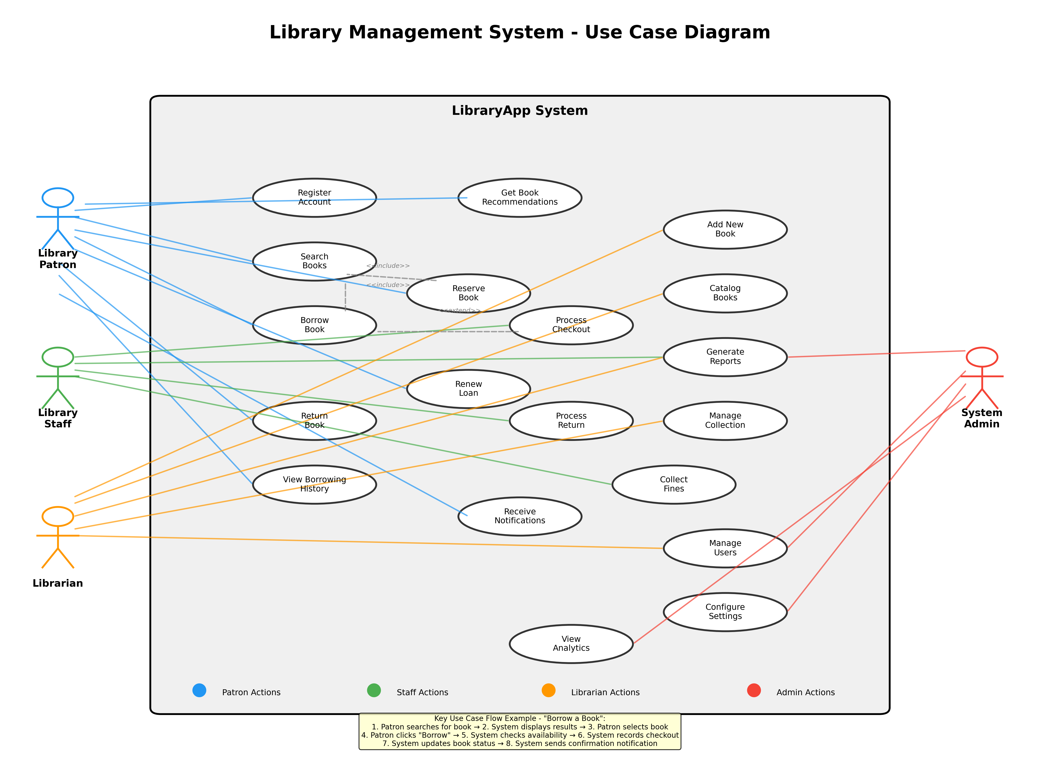

11. TOOLS AND TECHNOLOGIES USED

The LibraryApp system is built using **Python with Flask framework** for the backend API and server-side logic, **SQLite/PostgreSQL** for the database management system, **React Native with TypeScript** for the cross-platform mobile application (iOS/Android), and **React with Vite and TypeScript** for the web-based admin dashboard. Additional technologies include **scikit-learn and TextBlob** for machine learning-powered book recommendations and sentiment analysis, **Firebase Cloud Messaging (FCM)** for push notifications, **Git/GitHub** for version control, and cloud hosting services (AWS/DigitalOcean) for deployment, with the entire stack leveraging open-source technologies to ensure cost-effectiveness and scalability.

PHASE 2  
CLASS DIAGRAM

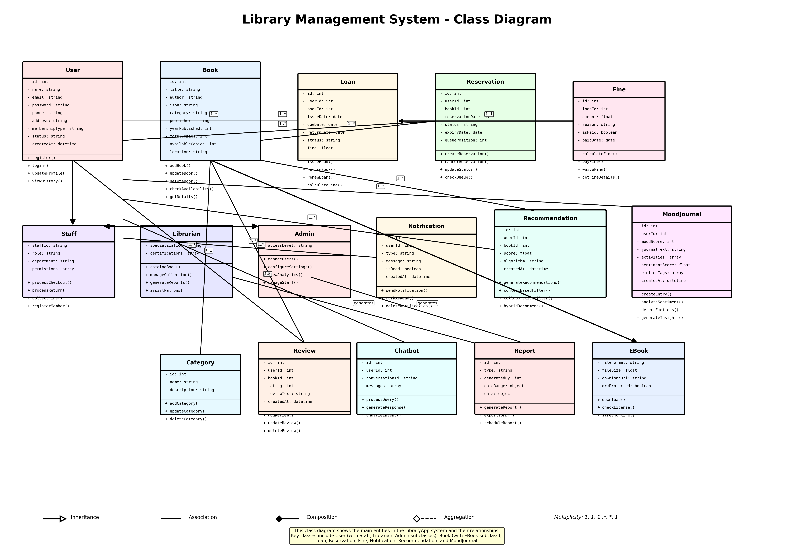

2.Sequence Diagram



STATE DIAGRAMS



ACTIVITY DIAGRAMS



COMPONENT DIAGRAMS



DEPLOYMENT DIAGRAM

